**SQL OUTPUTS**

1. Insert 5 records.

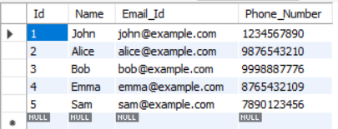

1. Modify Email_Id column to VARCHAR(30) NOT NULL.

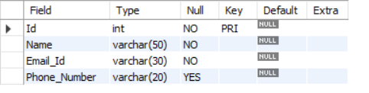

1. Insert 2 records and check.

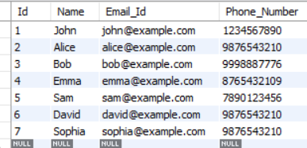

1. Update the name of employee Id 3 to Karthik and phone number to 1234567890.

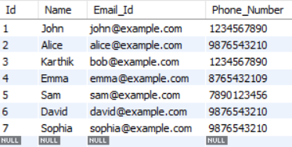

1. . Delete employee records 3 and 4.

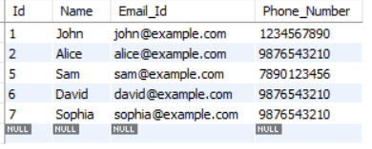

1. Remove all records from the table employee.

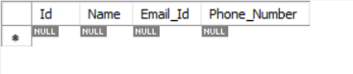

**JAVA OUTPUT**

